Lab 15 task 1: View a vSAN Datastore Configuration
You view an existing vSAN datastore configuration in the SA-Compute-01 cluster to familiarize yourself with where to find vSAN information in the vSphere Client.
1. Using the vSphere Client, log in to sa-vcsa-01.vclass.local by entering administrator@vsphere.local for the user name and VMware1! for the password.
2. Verify that vSAN is enabled on the SA-Compute-01 cluster.
a. From the Menu drop-down menu, select Hosts and Clusters.
b.In the navigation pane, expand SA-Datacenter and select SA-Compute-01.
c. In the right pane, click the Configure tab.
d. In the right pane under Configuration, select Quickstart.
e. Verify that vSAN appears as one of the selected services.
3. View the ESXi hosts that belong to the vSAN cluster.
a. in the right pane, click the Summary tab.
b. Expand the Cluster Resources pane and view the number of hosts in the vSAN cluster.
c. In the right pane, click the Hosts tab to view the names of the ESXi hosts in the cluster.
4. View the disk group configuration on the hosts in the vSAN cluster.
a. In the right pane, click the Configure tab.
b. Under vSAN, select Disk Management.
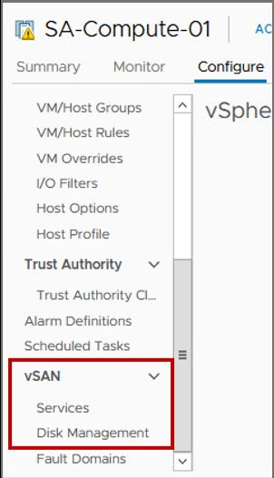
c. Under the first ESXi host in the list, select the disk group.
fsInformation about the disk group appears in the lower pane.
Q1. How many disks are in this disk group?
Q2. What are the disk drive types?
Q3. What disk tier does each drive belong to?
d. View the disk groups for the other ESXi hosts.
The number of disk drives, drive types, and tier assignments are the same as the first host.
5. View the VMkernel port configuration that is used to access the vSAN datastore.
a. In the navigation pane, select sa-esxi-04.vclass.local and, in the right pane, click the Configure tab.
b. In the right pane, under Networking, select VMkernel adapters.
c. Select vmk2 in the VMkernel adapters list.
d. Click the Properties tab.
e. Verify that vSAN appears as an enabled service.
6. View storage capacity information for the vSAN cluster.
a. In the navigation pane, select SA-Compute-01.
b. In the right pane, click the Summary tab.
c. Review the information on the vSAN Overview pane.
This pane shows current storage capacity used.
d. Under vSAN Capacity, click the Details link.
The Monitor tab appears and the Capacity Overview pane shows used space and free space in the vSAN cluster.

